Puppy Sale Agreement
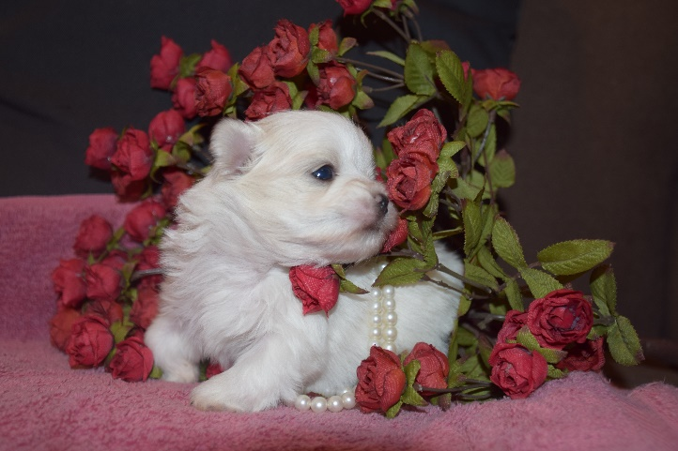

PUPPY BEING SOLD
Breed of the puppy: _Malshi
Gender of the puppy: ___________________
Date of birth of the puppy: ____/____/______

SELLER:
Tim and Bonnie Goold
406 880 9781
bonniekgoold.wixsite.com/qualitymalshi

BUYER:
Name: ___________________________________________

Address: _________________________________________

_________________________________________________

Phone: ___________________________Email:__________________________________

PURCHASE PRICE of the puppy is $________
Minus deposit amount of $400. Balance: $ ____________
Complete purchase price of the puppy paid on _____/_____/______

This transaction is final and will only be compromised conforming to the health guarantee contract.

Buyer’s Signature: ___________________________________ Date:_____/_____/_______

Seller’s Signature: ___________________________________ Date:_____/_____/_______
Health Guarantee:
- At eight weeks old the puppies are ready to go to their new home. By then they will have received plenty of tender, loving care, along with their first shots and worm prevention. It is our goal to provide enthusiastic, new pet owners with a happy, healthy puppy. If ever the health of any of our puppies come into question it will not be sold until it is clearly in good health.
- Upon the day the new owners receive their pup, they will have up to 60 hours to take their puppy to the veterinarian of their choice to verify the good health of the pup. If your puppy does not clear a puppy wellness check due to a serious condition which we are directly responsible for, we will allow you to return the puppy to us for a full refund. A document from a certified veterinarian verifying the puppy’s illness is required to receive the refund.
-Within the first year of the pup's life, if there develops a genetic defect which would greatly reduce quality or quantity of life, and with written verification by a professional veterinarian stating the cause to be hereditary, we will refund you half the price of the puppy and allow you to keep the puppy. This is the conclusion of the health guarantee we offer.

